**A photographic essay on important issue identified in the African community.**

1. **Education Disparities**

Disparities in access to quality education persist in Africa, particularly in rural areas and among marginalized communities. Ensuring universal access to education, improving educational infrastructure, and enhancing teacher training and support are crucial in promoting equitable educational opportunities and addressing the learning gap.

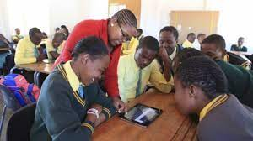

Education disparities prevalent in the African community are characterized by unequal access to quality educational resources and opportunities, stemming from factors such as inadequate funding, socioeconomic barriers, and cultural disconnects within the educational system

**Access to Quality Education**

Unequal Distribution of Resources

Capture images of schools in different neighborhoods, showcasing the contrast between well-funded schools and those lacking resources.

Capturing images of schools in various neighborhoods, displaying the contrast between well-funded institutions and those struggling with limited resources, vividly illustrates the educational disparities prevalent within the African community. These visuals underscore the unequal distribution of opportunities, facilities, and educational materials, highlighting the urgent need for equitable funding and resources to ensure that all students have access to quality education regardless of their socio-economic backgrounds.

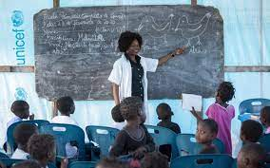 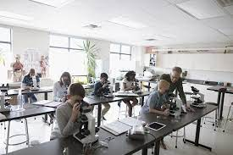

Infrastructure Disparities

Photographing classrooms, libraries, and facilities serves as a powerful visual tool to depict the stark differences in infrastructure and learning environments within the African community. These image capture the unequal allocation of resources, highlighting how well-equipped and conducive spaces in some schools contrast with inadequately furnished and limited facilities in others. The visuals emphasize the urgent need for investment in educational infrastructure to provide all students with an equitable and conducive learning environment.

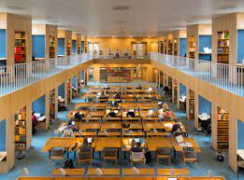

**Socioeconomic Impact**

Lack of Funding

The captured image below showcases outdated textbooks, overcrowded classrooms, and outdated technology, effectively illustrating the profound impact of insufficient funding on education within the African community. These visuals bring attention to the challenges students face in accessing up-to-date resources and the strained learning environment resulting from overcrowding. By highlighting these issues, the image underscores the critical importance of adequate funding to ensure that students receive a quality education that prepares them for a successful future.



Extracurricular Opportunities: Showcase the absence of extracurricular activities due to limited resources, impacting students' holistic development.

**Teacher Quality and Training**

Teacher-Student Interaction

The photographed interaction between teachers and students captures a poignant moment that underscores the significance of dedicated educators within the African community. These images emphasize the role of teachers as mentors, motivators, and guides in students' lives. By showcasing these interactions, the importance of nurturing relationships between educators and learners is illuminated, illustrating how committed teachers contribute to fostering a positive learning environment that nurtures growth, knowledge, and academic success.

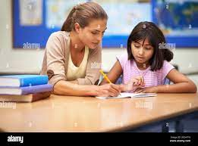 

Professional Development show educators attending workshops and training sessions, emphasizing the need for ongoing professional growth.

**Cultural Relevance**

Diverse Representation Captured image of diverse student bodies, showcasing the importance of culturally relevant curriculum and representation.

Diverse student bodies within the African community encompass a range of backgrounds, cultures, and experiences. These students bring unique perspectives to educational settings, reflecting a mosaic of ethnicities, languages, and traditions that enrich the learning environment.

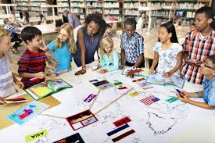

**Barriers to Education**

Long Commutes students walking long distances to reach school due to lack of nearby educational facilities.

Students walking long distances to reach school due to the absence of nearby educational facilities exemplify the challenges arising from limited access to quality education within certain African communities. The images highlight the dedication and determination of these students to overcome geographical barriers, underscoring the urgent need for improved infrastructure and equitable educational opportunities.

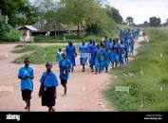 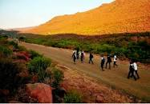

Socioeconomic Constraints students engaged in part-time jobs, illustrating the challenges they face in balancing work and studies.

**Community Involvement**

Parental Engagement

Showcasing parents actively engaged in school meetings and activities emphasizes the vital role of community support in fostering a holistic educational environment. These images illustrate the commitment of parents within the African community to contribute to their children's learning journey, reinforcing the idea that collaboration between schools and families is essential for creating well-rounded educational experiences and ensuring students' academic success.



Grassroots Initiatives: Photograph local organizations and community members working to bridge the education gap through mentorship and tutoring.

**Digital Divide**:

Lack of Technology

Capturing images of students without access to computers or the internet effectively highlights the profound impact of the digital divide on learning within the African community. These visuals draw attention to the disparities in technological access, illustrating how students without these resources face limitations in accessing online educational materials, remote learning opportunities, and digital skill development. By showcasing this divide, the images emphasize the urgent need for bridging the gap to ensure equitable access to digital tools, which are integral to modern education and future success.

 

Online Learning Challenges show students studying in unconventional spaces or struggling with virtual learning due to lack of resources.

**Success Stories and Resilience**:

Overcoming Challenges

Featuring image of students who have triumphed over challenges and excelled academically showcases their remarkable resilience within the African community. These images celebrate their determination to overcome obstacles such as limited resources, societal expectations, and systemic barriers. By spotlighting their achievements, the images inspire others to persevere, emphasizing the transformative power of education and the potential for every student to overcome adversity and achieve their dreams.

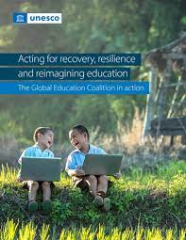

Role Models Photograph African educators, professionals, and graduates who are giving back to their communities and serving as role models.

Addressing education disparities in the African community is crucial for ensuring a fair and equitable society. By providing equal access to quality education, we empower individuals to reach their full potential, regardless of their background. This effort not only uplifts current generations but also sets a strong foundation for future ones. Eliminating these disparities can lead to increased economic opportunities, reduced social inequalities, and a more diverse and educated workforce, ultimately fostering sustainable development and progress for the entire African community.